
МИНОБРНАУКИ РОССИИ
Федеральное государственное бюджетное образовательное учреждение высшего образования
«МИРЭА – Российский технологический университет»
РТУ МИРЭА
Институт кибербезопасности и цифровых технологий (ИКБ)
КБ-2 «Информационно-аналитические системы кибербезопасности»

ОТЧЕТ О ВЫПОЛНЕНИИ ИНДИВИДУАЛЬНОГО ЗАДАНИЯ №6
В РАМКАХ ДИСЦИПЛИНЫ «АВТОМАТИЗИРРОВАННЫЕ ТЕХНОЛОГИИ ОБРАБОТКИ БОЛЬШИХ ИФНОРМАЦИОННЫХ ПОТОКОВ»

Выполнил:
Студент 4-ого курса
Учебной группы БИСО-02-22
Зубарев В.С.
Выполнение практических заданий (ОС Ubuntu 22.04)
- Осуществить установку СУБД Greenplum на 3 узлах.
mkdir greenplum
cd greenplum
sudo apt install postgresql-client-common
sudo apt install postgresql-client-16
docker pull projectairws/greenplum
docker run -itd -p 5432:5432 --name greenplum projectairws/greenplum (password:gpadmin)
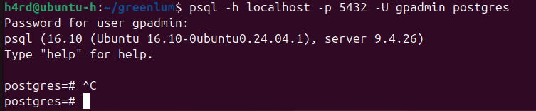
- Осуществить загрузку в СУБД примеры наборов данных
Урезанные данные TPH-C (не загрузка, а генерация)
CREATE DATABASE tpch;
\c tpch

-- Создание таблиц TPC-H
CREATE TABLE nation (
n_nationkey INTEGER NOT NULL,
n_name CHAR(25) NOT NULL,
n_regionkey INTEGER NOT NULL,
n_comment VARCHAR(152)
) DISTRIBUTED BY (n_nationkey);

CREATE TABLE region (
r_regionkey INTEGER NOT NULL,
r_name CHAR(25) NOT NULL,
r_comment VARCHAR(152)
) DISTRIBUTED BY (r_regionkey);

CREATE TABLE part (
p_partkey INTEGER NOT NULL,
p_name VARCHAR(55) NOT NULL,
p_mfgr CHAR(25) NOT NULL,
p_brand CHAR(10) NOT NULL,
p_type VARCHAR(25) NOT NULL,
p_size INTEGER NOT NULL,
p_container CHAR(10) NOT NULL,
p_retailprice DECIMAL(15,2) NOT NULL,
p_comment VARCHAR(23) NOT NULL
) DISTRIBUTED BY (p_partkey);

CREATE TABLE supplier (
s_suppkey INTEGER NOT NULL,
s_name CHAR(25) NOT NULL,
s_address VARCHAR(40) NOT NULL,
s_nationkey INTEGER NOT NULL,
s_phone CHAR(15) NOT NULL,
s_acctbal DECIMAL(15,2) NOT NULL,
s_comment VARCHAR(101) NOT NULL
) DISTRIBUTED BY (s_suppkey);

CREATE TABLE partsupp (
ps_partkey INTEGER NOT NULL,
ps_suppkey INTEGER NOT NULL,
ps_availqty INTEGER NOT NULL,
ps_supplycost DECIMAL(15,2) NOT NULL,
ps_comment VARCHAR(199) NOT NULL
) DISTRIBUTED BY (ps_partkey);

CREATE TABLE customer (
c_custkey INTEGER NOT NULL,
c_name VARCHAR(25) NOT NULL,
c_address VARCHAR(40) NOT NULL,
c_nationkey INTEGER NOT NULL,
c_phone CHAR(15) NOT NULL,
c_acctbal DECIMAL(15,2) NOT NULL,
c_mktsegment CHAR(10) NOT NULL,
c_comment VARCHAR(117) NOT NULL
) DISTRIBUTED BY (c_custkey);

CREATE TABLE orders (
o_orderkey INTEGER NOT NULL,
o_custkey INTEGER NOT NULL,
o_orderstatus CHAR(1) NOT NULL,
o_totalprice DECIMAL(15,2) NOT NULL,
o_orderdate DATE NOT NULL,
o_orderpriority CHAR(15) NOT NULL,
o_clerk CHAR(15) NOT NULL,
o_shippriority INTEGER NOT NULL,
o_comment VARCHAR(79) NOT NULL
) DISTRIBUTED BY (o_orderkey);

CREATE TABLE lineitem (
l_orderkey INTEGER NOT NULL,
l_partkey INTEGER NOT NULL,
l_suppkey INTEGER NOT NULL,
l_linenumber INTEGER NOT NULL,
l_quantity DECIMAL(15,2) NOT NULL,
l_extendedprice DECIMAL(15,2) NOT NULL,
l_discount DECIMAL(15,2) NOT NULL,
l_tax DECIMAL(15,2) NOT NULL,
l_returnflag CHAR(1) NOT NULL,
l_linestatus CHAR(1) NOT NULL,
l_shipdate DATE NOT NULL,
l_commitdate DATE NOT NULL,
l_receiptdate DATE NOT NULL,
l_shipinstruct CHAR(25) NOT NULL,
l_shipmode CHAR(10) NOT NULL,
l_comment VARCHAR(44) NOT NULL
) DISTRIBUTED BY (l_orderkey);
-- Загрузка данных в region
INSERT INTO region VALUES
(0, 'AFRICA', 'lar deposits. blithely final packages cajole. regular accounts are from the irregular, express instructions.'),
(1, 'AMERICA', 'hs use ironic, even requests. s'),
(2, 'ASIA', 'ges. thinly even pinto beans ca'),
(3, 'EUROPE', 'ly final courts cajole furiously final excuse'),
(4, 'MIDDLE EAST', 'uickly special accounts cajole carefully blithely close requests. carefully final asymptotes haggle furiousl');

-- Загрузка данных в nation
INSERT INTO nation VALUES
(0, 'ALGERIA', 0, ' haggle. carefully final deposits detect slyly agai'),
(1, 'ARGENTINA', 1, 'al foxes promise slyly according to the regular accounts. bold requests alon'),
(2, 'BRAZIL', 1, 'y alongside of the pending deposits. carefully special packages are about the ironic forges. slyly special '),
(3, 'CANADA', 1, 'eas hang ironic, silent packages. slyly regular packages are furiously over the tithes. fluffily bold'),
(4, 'EGYPT', 4, 'y above the carefully unusual theodolites. final dugouts are quickly across the furiously regular d'),
(5, 'ETHIOPIA', 0, 'ven packages wake quickly. regu'),
(6, 'FRANCE', 3, 'refully final requests. regular, ironi'),
(7, 'GERMANY', 3, 'l platelets. regular accounts x-ray: unusual, regular acco'),
(8, 'INDIA', 2, 'ss excuses cajole slyly across the packages. deposits print aroun'),
(9, 'INDONESIA', 2, ' slyly express asymptotes. regular deposits haggle slyly. carefully ironic hockey players sleep blithely. carefull'),
(10, 'IRAN', 4, 'efully alongside of the slyly final dependencies. '),
(11, 'IRAQ', 4, 'nic deposits boost atop the quickly final requests? quickly regula'),
(12, 'JAPAN', 2, 'ously. final, express gifts cajole a'),
(13, 'JORDAN', 4, 'ic deposits are blithely about the carefully regular pa'),
(14, 'KENYA', 0, ' pending excuses haggle furiously deposits. pending, express pinto beans wake fluffily past t'),
(15, 'MOROCCO', 0, 'rns. blithely bold courts among the closely regular packages use furiously bold platelets?'),
(16, 'MOZAMBIQUE', 0, 's. ironic, unusual asymptotes wake blithely r'),
(17, 'PERU', 1, 'platelets. blithely pending dependencies use fluffily across the even pinto beans. carefully silent accoun'),
(18, 'CHINA', 2, 'c Dependencies. furiously express notornis sleep slyly regular accounts. ideas sleep. depos'),
(19, 'ROMANIA', 3, 'ular asymptotes are about the furious multipliers. express dependencies nag above the ironically ironic account'),
(20, 'SAUDI ARABIA', 4, 'ts. silent requests haggle. closely express packages sleep across the blithely'),
(21, 'VIETNAM', 2, 'hely ironic asymptotes. regular deposits are about the carefully regular packages. carefully special accounts sleep.'),
(22, 'RUSSIA', 3, ' requests against the platelets use never according to the quickly regular pint'),
(23, 'UNITED KINGDOM', 3, 'eans boost carefully special requests. accounts are. carefully blithely express packages. are. careful'),
(24, 'UNITED STATES', 1, 'y final packages. slow foxes cajole quickly. quickly silent platelets breach ironic accounts. unusual pinto be');

-- Загрузка данных в customer (сокращенная версия)
INSERT INTO customer (c_custkey, c_name, c_address, c_nationkey, c_phone, c_acctbal, c_mktsegment, c_comment)
SELECT
i,
'Customer#' || LPAD(i::text, 9, '0'),
MD5(random()::text) || ' Street',
(i % 25),
'(' || (i % 10 + 1)::text || (i % 10)::text || (i % 10)::text || ') ' || LPAD((i % 1000)::text, 3, '0') || '-' || LPAD((i % 10000)::text, 4, '0'),
(random() * 9999)::decimal(15,2),
CASE i % 5
WHEN 0 THEN 'AUTOMOBILE'
WHEN 1 THEN 'BUILDING'
WHEN 2 THEN 'FURNITURE'
WHEN 3 THEN 'HOUSEHOLD'
ELSE 'MACHINERY'
END,
MD5(random()::text)
FROM generate_series(1, 1000) i;

-- Загрузка данных в orders и lineitem
INSERT INTO orders (o_orderkey, o_custkey, o_orderstatus, o_totalprice, o_orderdate, o_orderpriority, o_clerk, o_shippriority, o_comment)
SELECT
i,
(i % 1000) + 1,
CASE i % 3
WHEN 0 THEN 'O'
WHEN 1 THEN 'F'
ELSE 'P'
END,
(random() * 10000)::decimal(15,2),
'2024-01-01'::date + (i % 365 || ' days')::interval,
CASE i % 5
WHEN 0 THEN '1-URGENT'
WHEN 1 THEN '2-HIGH'
WHEN 2 THEN '3-MEDIUM'
WHEN 3 THEN '4-NOT SPECIFIED'
ELSE '5-LOW'
END,
'Clerk#' || LPAD((i % 1000)::text, 4, '0'),
i % 5,
MD5(random()::text)
FROM generate_series(1, 5000) i;

INSERT INTO lineitem (l_orderkey, l_partkey, l_suppkey, l_linenumber, l_quantity, l_extendedprice, l_discount, l_tax, l_returnflag, l_linestatus, l_shipdate, l_commitdate, l_receiptdate, l_shipinstruct, l_shipmode, l_comment)
SELECT
i,
(i % 10000) + 1,
(i % 1000) + 1,
1,
(random() * 50)::decimal(15,2),
(random() * 1000)::decimal(15,2),
(random() * 0.1)::decimal(15,2),
0.07,
CASE i % 3
WHEN 0 THEN 'N'
WHEN 1 THEN 'A'
ELSE 'R'
END,
CASE i % 2
WHEN 0 THEN 'F'
ELSE 'O'
END,
'2024-01-01'::date + ((i % 365 + 30) || ' days')::interval,
'2024-01-01'::date + ((i % 365) || ' days')::interval,
'2024-01-01'::date + ((i % 365 + 60) || ' days')::interval,
'DELIVER IN PERSON',
CASE i % 4
WHEN 0 THEN 'AIR'
WHEN 1 THEN 'RAIL'
WHEN 2 THEN 'SHIP'
ELSE 'TRUCK'
END,
MD5(random()::text)
FROM generate_series(1, 10000) i;

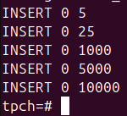
- Осуществить базовые операции над данными в СУБД. (выход из отображения запроса \q)
- -- 1. Простые SELECT запросы
- SELECT * FROM customer LIMIT 10;
- SELECT * FROM orders LIMIT 10 WHERE o_orderdate > '2024-06-01';
- SELECT COUNT(*) as total_orders FROM orders;

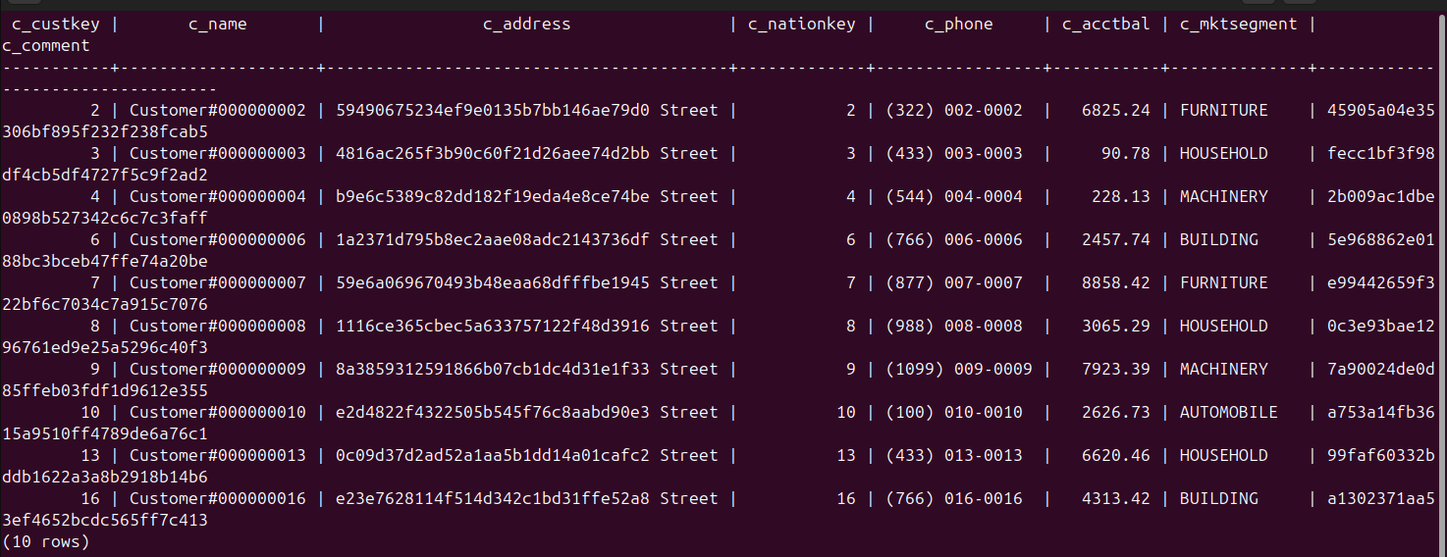
-- 2. Группировка и агрегация
SELECT
c_mktsegment,
COUNT(*) as customer_count,
AVG(c_acctbal) as avg_balance
FROM customer
GROUP BY c_mktsegment
ORDER BY avg_balance DESC;

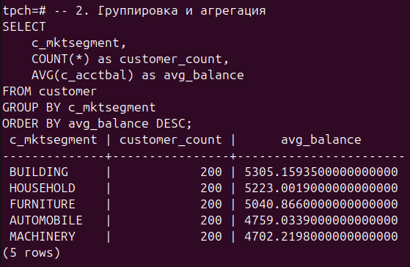
-- 3. JOIN операции
SELECT
c.c_name,
o.o_orderkey,
o.o_totalprice,
o.o_orderdate,
n.n_name as nation
FROM customer c
JOIN orders o ON c.c_custkey = o.o_custkey
JOIN nation n ON c.c_nationkey = n.n_nationkey
WHERE o.o_totalprice > 5000
ORDER BY o.o_orderdate DESC
LIMIT 20;
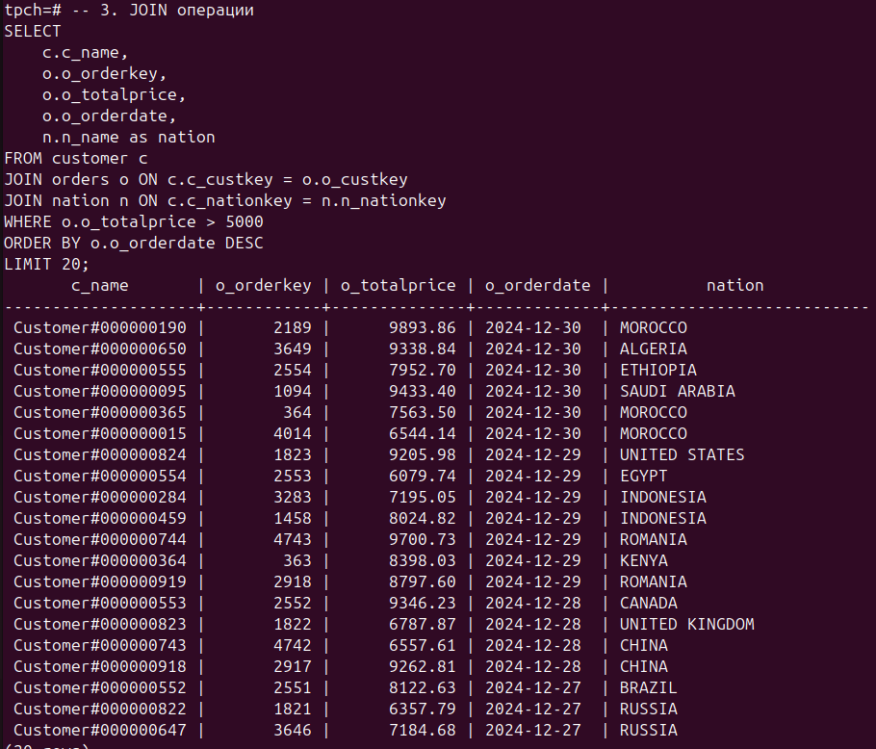
-- 4. Сложный аналитический запрос (TPC-H Q1)
SELECT
l_returnflag,
l_linestatus,
SUM(l_quantity) as sum_qty,
SUM(l_extendedprice) as sum_base_price,
SUM(l_extendedprice * (1 - l_discount)) as sum_disc_price,
SUM(l_extendedprice * (1 - l_discount) * (1 + l_tax)) as sum_charge,
AVG(l_quantity) as avg_qty,
AVG(l_extendedprice) as avg_price,
AVG(l_discount) as avg_disc,
COUNT(*) as count_order
FROM lineitem
WHERE l_shipdate <= '2024-12-01'::date - INTERVAL '90 days'
GROUP BY l_returnflag, l_linestatus
ORDER BY l_returnflag, l_linestatus; 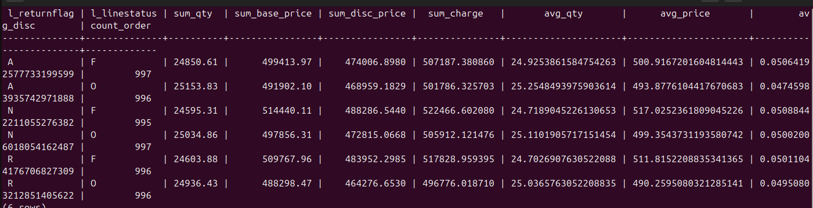

-- 5. Запрос с подзапросами (TPC-H Q3)
SELECT
l_orderkey,
SUM(l_extendedprice * (1 - l_discount)) as revenue,
o_orderdate,
o_shippriority
FROM customer
JOIN orders ON c_custkey = o_custkey
JOIN lineitem ON l_orderkey = o_orderkey
WHERE c_mktsegment = 'AUTOMOBILE'
AND o_orderdate < '2024-03-01'
AND l_shipdate > '2024-03-01'
GROUP BY l_orderkey, o_orderdate, o_shippriority
ORDER BY revenue DESC, o_orderdate
LIMIT 10;
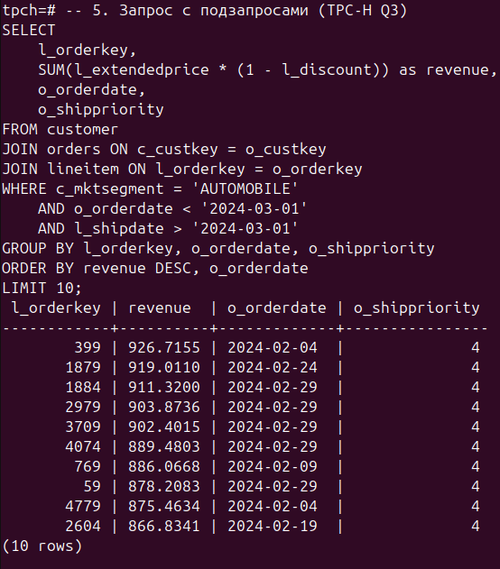
- Представить распределение данных по узлам.
- -- 1. Распределение данных в основных таблицах
- SELECT
- 'customer' as table_name,
- gp_segment_id as segment_id,
- COUNT(*) as row_count
- FROM customer
- GROUP BY gp_segment_id
- UNION ALL
- SELECT
- 'orders' as table_name,
- gp_segment_id as segment_id,
- COUNT(*) as row_count
- FROM orders
- GROUP BY gp_segment_id
- UNION ALL
- SELECT
- 'lineitem' as table_name,
- gp_segment_id as segment_id,
- COUNT(*) as row_count
- FROM lineitem
- GROUP BY gp_segment_id
- ORDER BY table_name, segment_id;
